Lab Report 0

Ben Johnson

Software

Part 2:

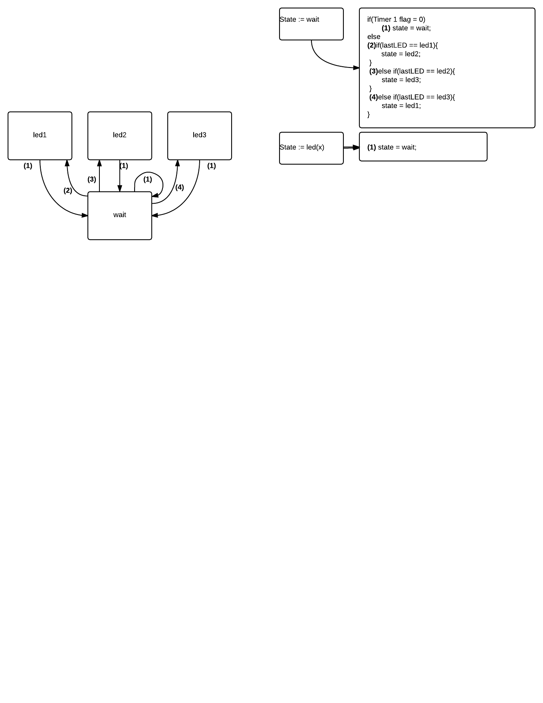

Part 3: